# CS 255 System Design Document Template

This template lays out all the different sections that you need to complete for Project Two. Each section has guidance to prompt your thinking. You will need to continually reference the interview transcript as you work to make sure that you are addressing your client’s needs. There is no required length for the final document. Instead the goal is to complete each section based on what your client’s needs are. Remove this note when you are finished, and replace all bracketed text with the relevant information.

## UML Diagrams

### UML Use Case Diagram

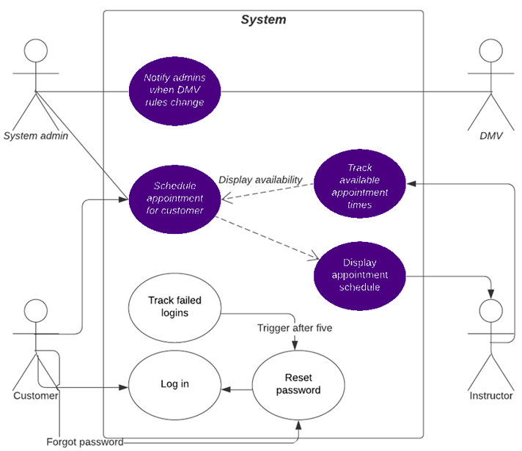

### UML Activity Diagrams

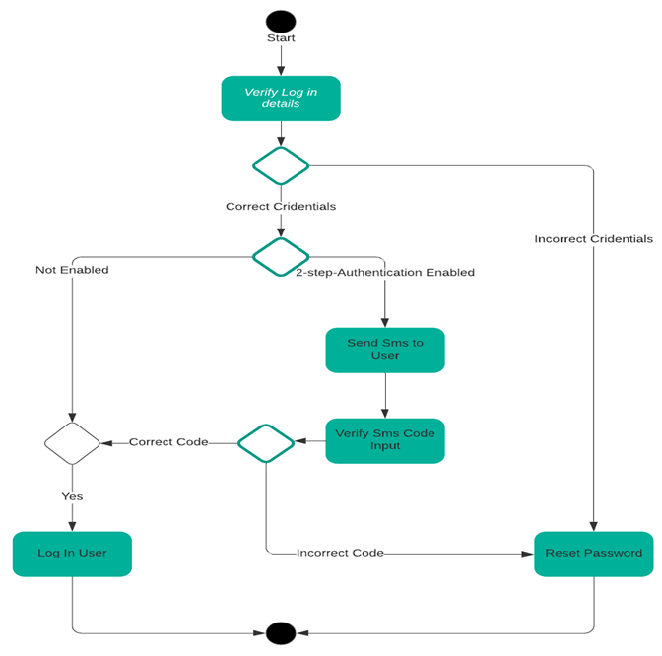

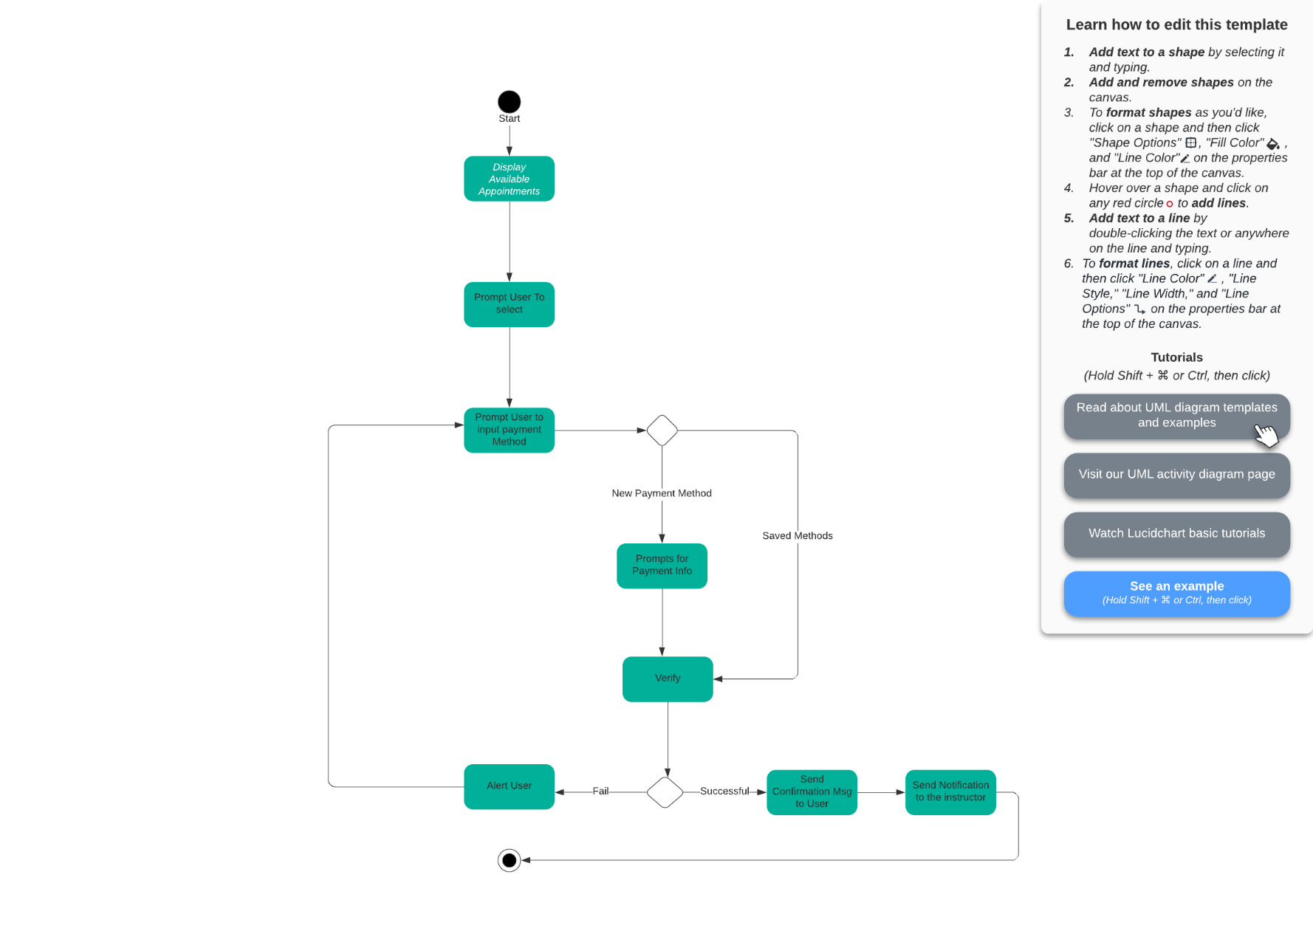

### UML Sequence Diagram

## 

**UML CLASS DIAGRAM**

## Technical Requirements

The system has several key technological needs to ensure seamless functionality. A host machine is essential for running the backend database and web interface. The system will be developed for both the web using the cloud and a mobile version, allowing the owner to access downloaded data on the go. A stable and reliable internet connection is required to support real-time updates, such as the training calendar for scheduling appointments and the tracker for user training progress.

A database, either cloud based or housed in a physical data center, will store login credentials and other critical information. To maintain data integrity and security, all data exchanged between users and the system must be encrypted using SSL. Additionally, role based access control will be implemented to ensure that different users such as owners, administrators, instructors, and customers have appropriate access levels.

For financial transactions, the system will require a service capable of payment processing. Office staff must also have computer access to a web browser to interact with the system’s interface efficiently.